BYOP AI BASED EYECARE REMINDER SYSTEM PROJECT REPORT

NAME : MANIKANTA MADHAV . K

REG NO : 25BAI10277

COURSE : BTECH CSE(AIML)

INSTITUTION : VIT BHOPAL

DATE : March 24, 2026

INDEX

- Abstract
- Introduction
- Problem Statement
- Objective
- Methodology
- Technologies Used
- Project Structure
- Features
- Results
- Applications
- Limitations
- Future Enhancements
- Conclusion
- References

Abstract
along with periodic reminders. The project demonstrates the practical application of programming concepts to solve real-world health issues. In today’s digital world, prolonged screen exposure leads to various eye-related problems such as dryness, irritation, and eye strain. This project presents an AI-based Eye Care Reminder System that helps users maintain healthy eye habits. The system collects user inputs related to screen usage and symptoms, analyzes them using simple decision logic, and provides personalized suggestions

Problem Statement
Many individuals, especially students and professionals, spend long hours in front of screens without taking adequate breaks. This results in eye strain and long-term vision problems. There is a need for a simple, intelligent system that can remind users to take care of their eyes and provide basic guidance based on symptoms.

Objective
- To develop a system that monitors screen usage habits
- To detect possible eye conditions based on user input
- To provide personalized suggestions for eye care
- To implement a reminder system for regular breaks
- To solve a personal problem

Methodology
Step 1: Input Collection
The system collects:
- Daily screen usage hours
- Symptoms (dryness, redness, itching)
Step 2: Condition Detection
Using conditional logic:
- Dryness + Redness → Dry Eye Syndrome
- Itching → Eye Allergy
- Otherwise → Normal Eye Strain
Step 3: Decision Making
Based on usage:
- High usage → Frequent reminders
- Normal usage → Moderate reminders
Step 4: Output Generation
- Displays detected condition
- Provides suggestions
- Starts reminder loop

Technologies Used
- Python – Core programming
- Git & GitHub – Version control
- VS Code – Development environment

Project Structure
BYOP Eye Care
main.py → Main logic
reminder.py → Reminder system
logger.py → Data logging
data.txt → Stores user data
README.md → Documentation

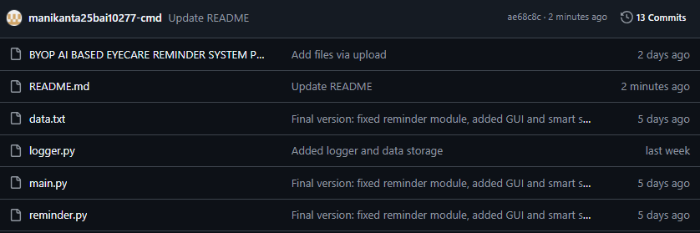

Features
- Intelligent condition detection
- Personalized eye care suggestions
- Continuous reminder system
- Modular programming design
- Version-controlled project

SOURCE CODE :

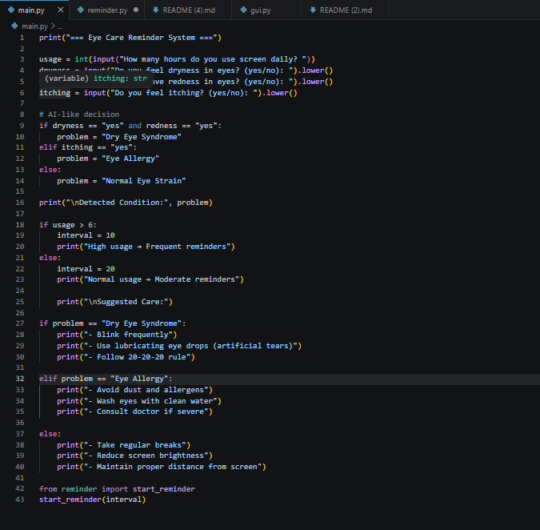

Results
The system successfully:
- Detects basic eye conditions
- Provides relevant suggestions
- Reminds users at regular intervals
The output is displayed clearly in terminal .
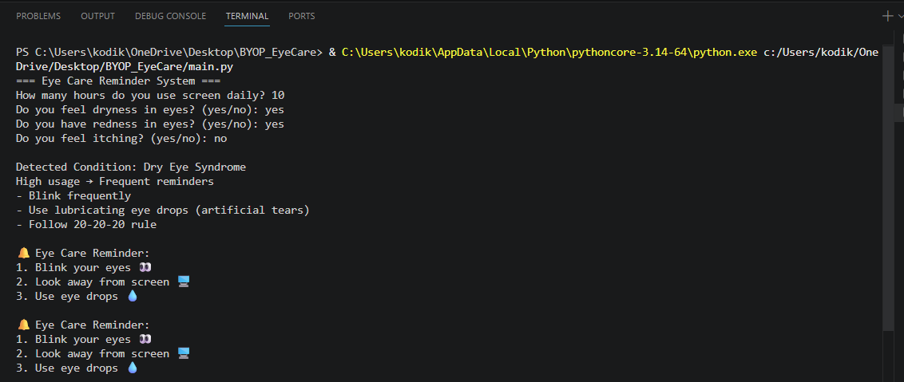

Applications
- Students using laptops for studies
- Office employees
- Gamers and heavy screen users
- General public

Limitations
- Uses basic logic instead of advanced AI
- Requires manual input from user
- No real-time eye tracking

Future Enhancements
- Integration with webcam for real-time detection
- Mobile app version
- Notification pop-ups
- Machine learning-based prediction

Conclusion
- The project demonstrates how programming can be applied to solve real-life health problems. The AI-based Eye Care Reminder System is simple, effective, and user-friendly. It encourages healthy screen habits and showcases the practical use of logic, modular programming.

References
- Python Documentation
- GitHub Guides

